Tutorial 7

Module Name: Name Validation Module – Boundary Value Analysis &
Equivalence Partitioning
Test Case ID: TC07
Tester Name: Vora Riya

Scenarios:
- Scenario ID: BVA01
Scenario
Verify age just below minimum boundary
Test Steps
1. Open JustValidate Playground.
2. Enter valid Name, Email and Password.
3. Enter Age as 17.
4. Observe validation.

Actual Result
Age was rejected and validation message “Number should be more or equal than 18” was displayed.

Status
Pass
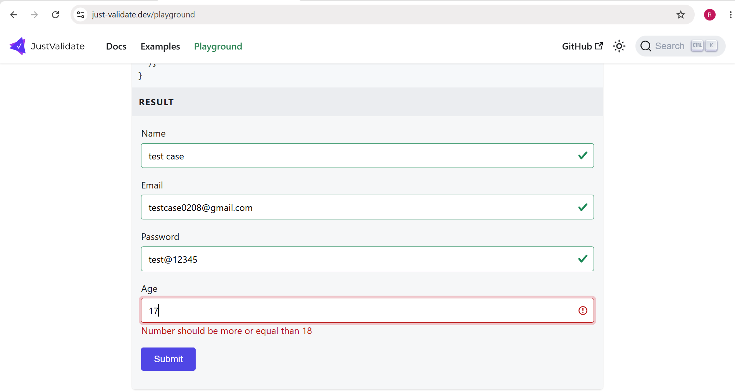

- Scenario ID: BVA02
Scenario
Verify minimum valid age
Test Steps
1. Enter valid Name, Email and Password.
2. Enter Age as 18.
3. Observe validation.
Actual Result
Age 18 was accepted and a green validation check was displayed.
Status
Pass

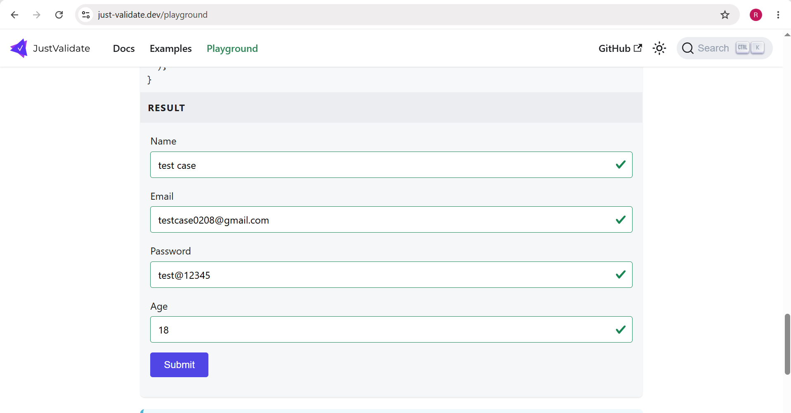

- Scenario ID: BVA03
Scenario
Verify age just above minimum boundary
Test Steps
1. Enter valid Name, Email and Password.
2. Enter Age as 19.
3. Observe validation.
Actual Result
Age 19 was accepted and a green validation check was displayed.
Status
Pass
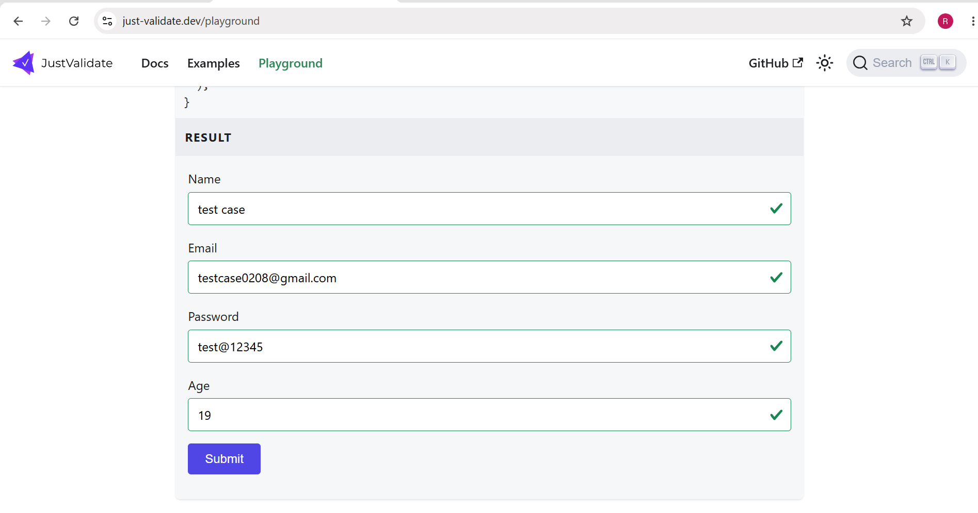

- Scenario ID: BVA04
Scenario
Verify age just below maximum boundary
Test Steps
1. Enter valid Name, Email and Password.
2. Enter Age as 59.
3. Observe validation.
Actual Result
Age 59 was accepted and a green validation check was displayed.
Status
Pass
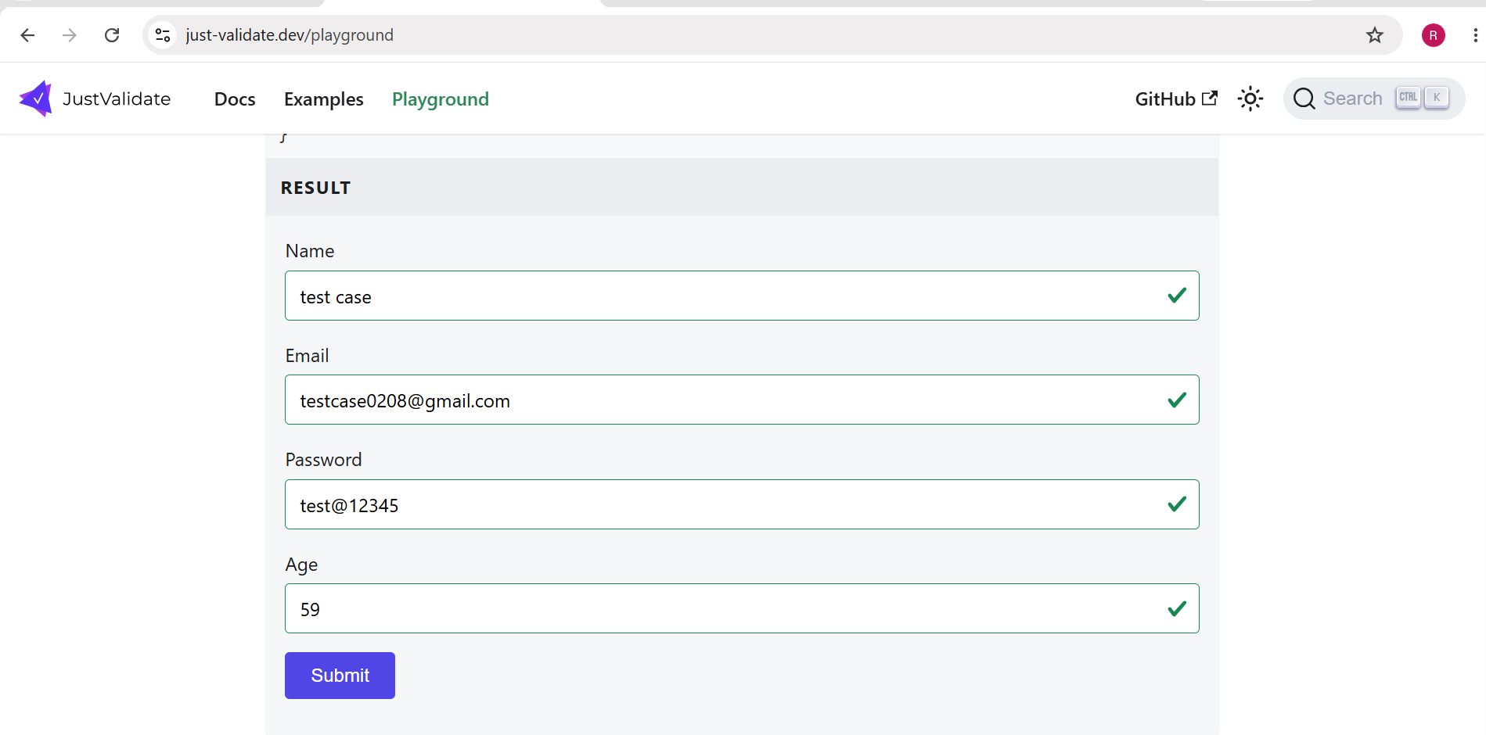

- Scenario ID: BVA05
Scenario
Verify maximum valid age
Test Steps
1. Enter valid Name, Email and Password.
2. Enter Age as 60.
3. Observe validation.
Actual Result
Age 60 was accepted and a green validation check was displayed.
Status
Pass
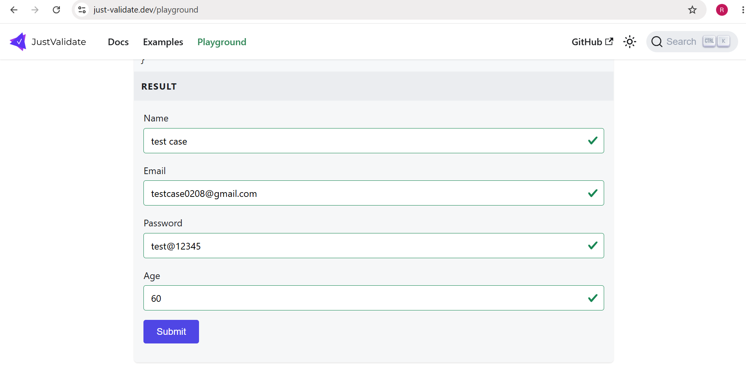

- Scenario ID: BVA06
Scenario
Verify age just above maximum boundary
Test Steps
1. Enter valid Name, Email and Password.
2. Enter Age as 61.
3. Observe validation.
Actual Result
Age was rejected and validation message “Number should be less or equal than 60” was displayed.
Status
Pass
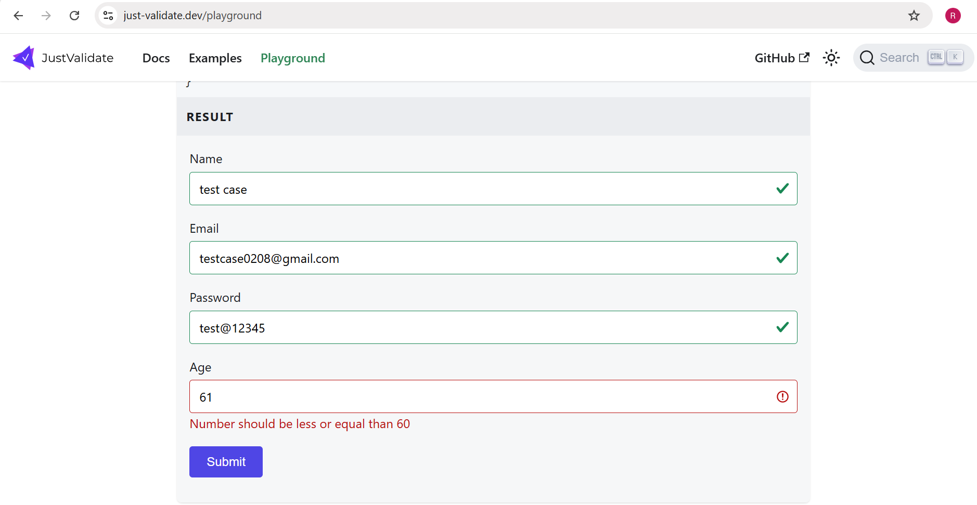

- Scenario ID: EP01
Scenario
Verify invalid equivalence class below minimum age
Test Steps
1. Enter valid Name, Email and Password.
2. Enter Age as 15.
3. Observe validation.
Actual Result
Age 15 was rejected and validation message “Number should be more or equal than 18” was displayed.
Status
Pass
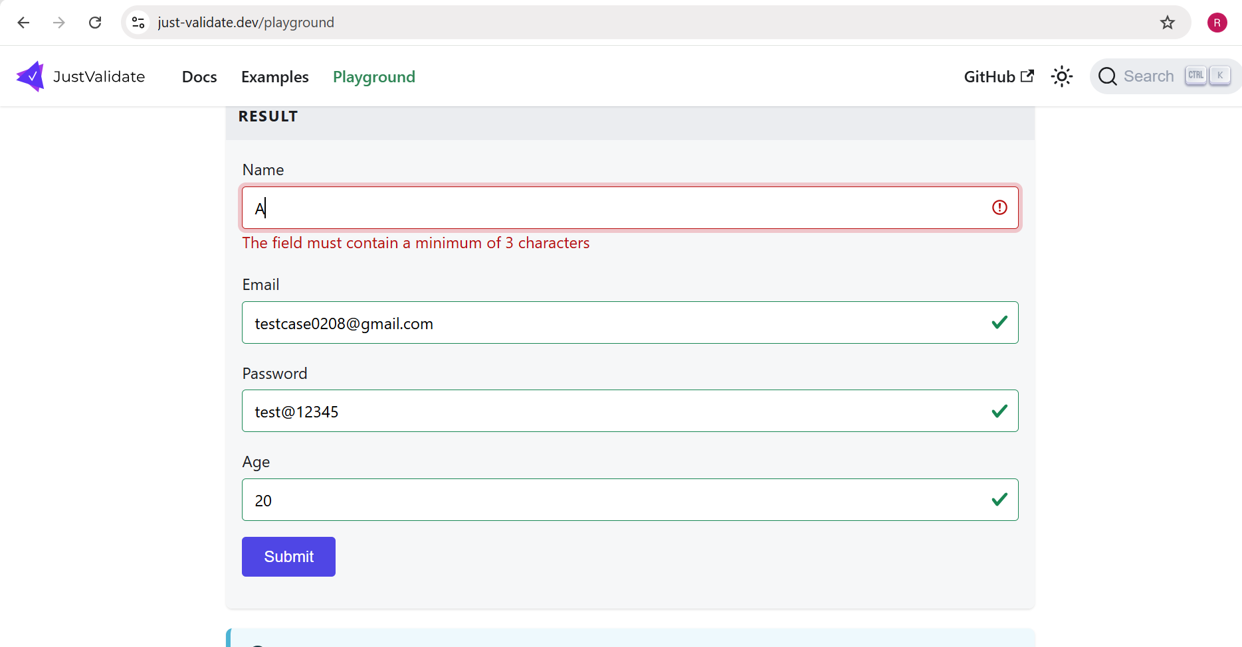

- Scenario ID: EP02
Scenario
Verify valid equivalence class
Test Steps
1. Enter valid Name, Email and Password.
2. Enter Age as 30.
3. Observe validation.
Actual Result
Age 30 was accepted and a green validation check was displayed.
Status
Pass

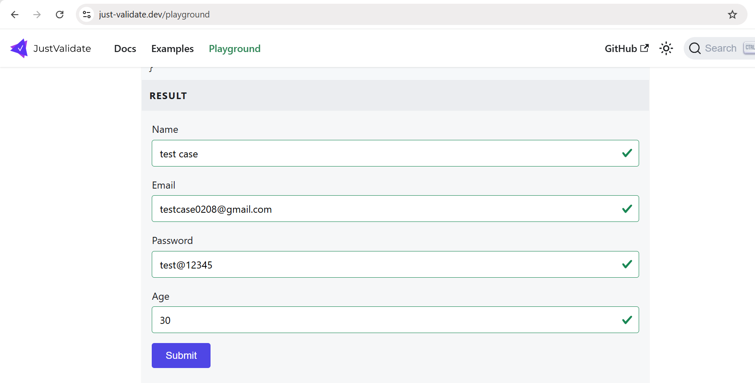

- Scenario ID: EP03
Scenario
Verify invalid equivalence class above maximum age
Test Steps
1. Enter valid Name, Email and Password.
2. Enter Age as 65.
3. Observe validation.
Actual Result
Age 65 was rejected and validation message “Number should be less or equal than 60” was displayed.
Status
Pass
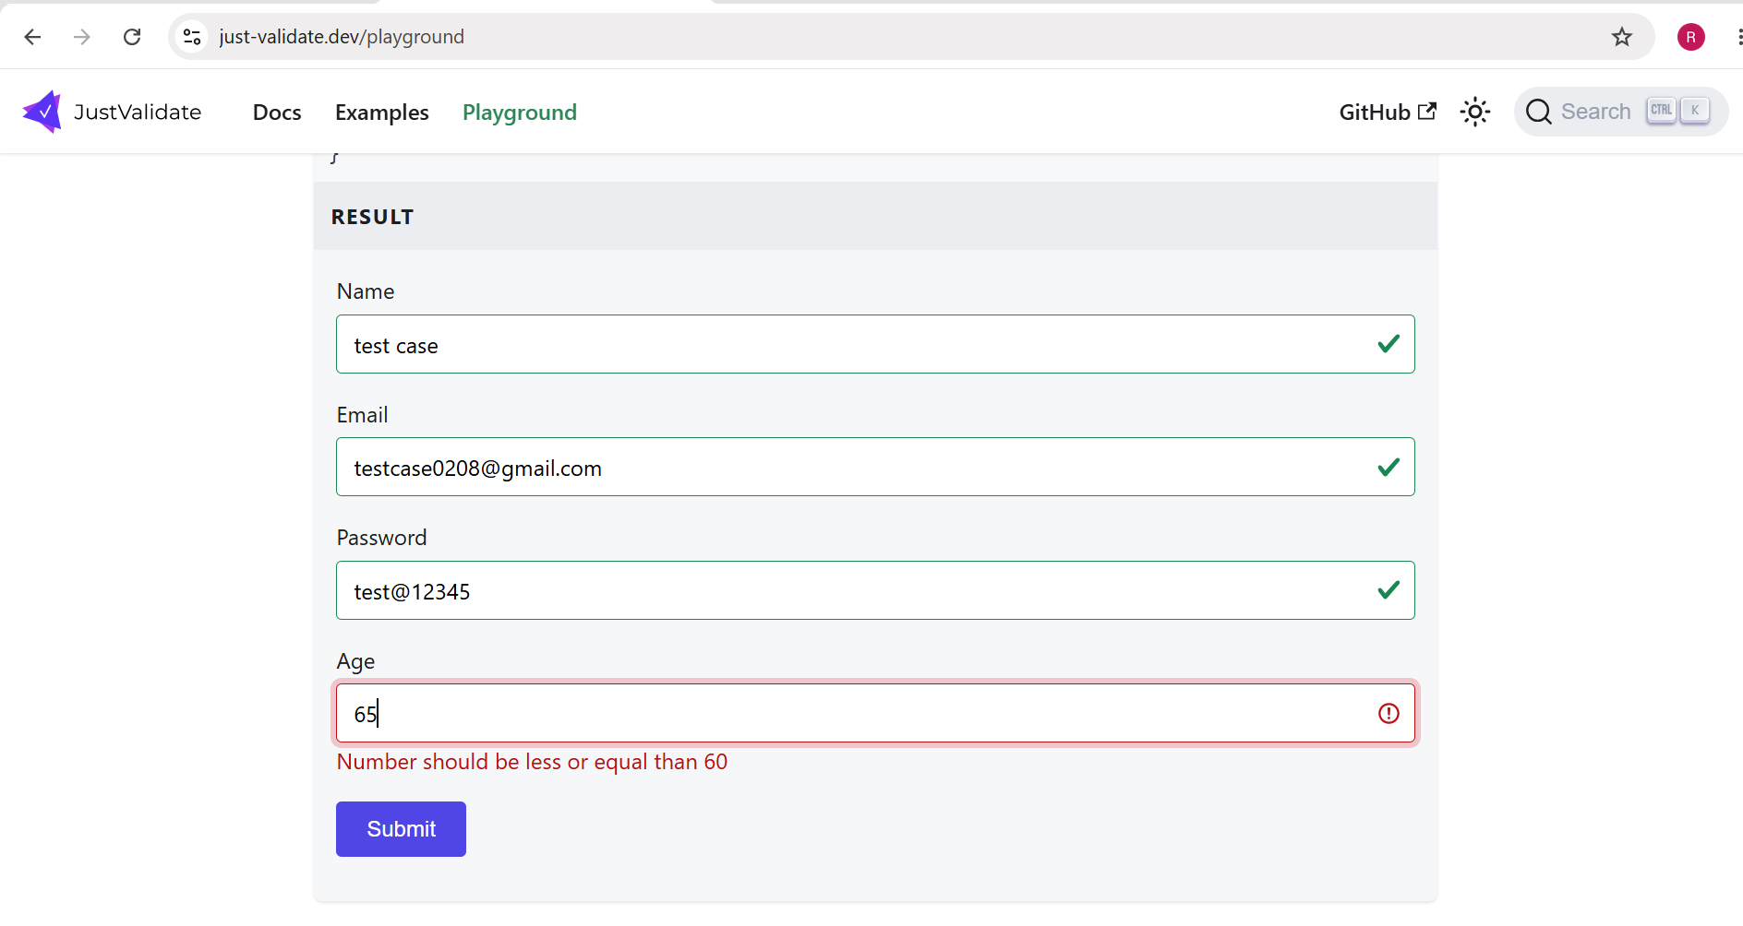

Test Result Summary

Total Test Case | Pass | Fail
9 | 9 | 0

Input Field | Input Range / Condition | Equivalence Class Type | Test Value | Expected Result
Age | Less than 18 | Invalid | 17 | Reject
Age | 18-60 | Valid | 19 | Accept
Age | More than 60 | Invalid | 65 | Reject

